Cyngor Cymuned Llanbradach a Phwllypant
Llanbradach & Pwllypant Community Council

Llanbradach Ward

Notice of Vacancy

Notice is hereby given that a vacancy has arisen in the Llanbradach ward of the abovementioned Council.

An election will be held to fill the vacancy if notice is given in writing to the Returning Officer, at the address below, by TEN Local Government Electors from that ward within fourteen days from the date of this notice.

If such notice has not been received by 4th December 2023, Llanbradach & Pwllypant Community Council will fill the vacancy by co-option.

Anyone interested in co-option to the Council should contact the Clerk to the Council at the address below.

Dated: 14th November 2023

Signed:

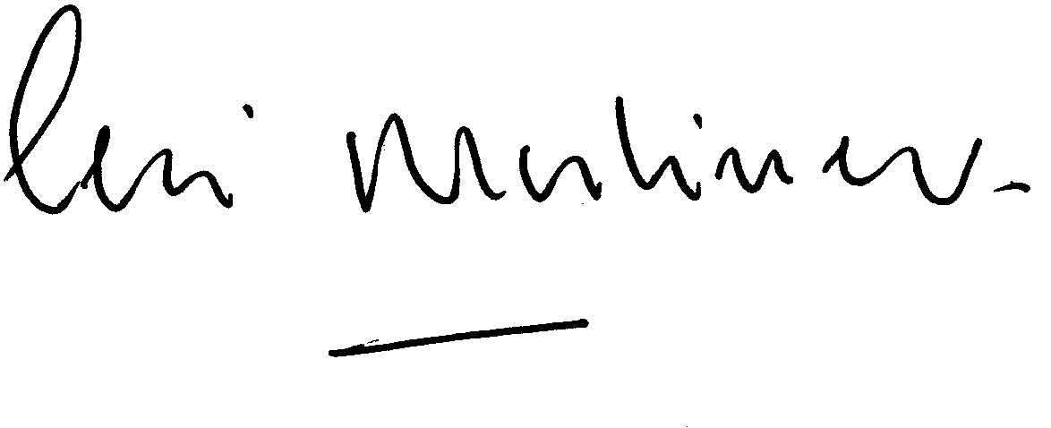

C Harrhy C Mortimer
Returning Officer Clerk to the Council
Caerphilly County Borough Council Llanbradach & Pwllypant Community Council
Bargoed House C/o 38 Nant Fawr Road
1 St Gwladys Way Cyncoed
Bargoed Cardiff
CF81 8AB CF23 JR

Printed and Published by Llanbradach & Pwllypant Community Council

